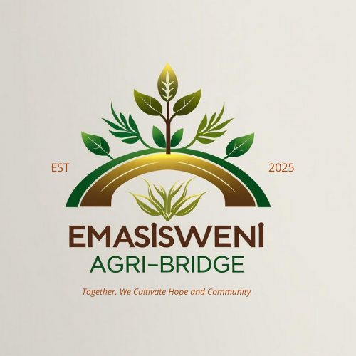
Emasisweni Agri-Bridge NPC

1. Company Overview
Emasisweni Agri-Bridge Non-Profit Company (NPC) is a community-driven agricultural organization based in Impendle, KwaZulu-Natal, South Africa. Established to create inclusive opportunities across the agricultural value chain, the NPC focuses on empowering smallholder farmers, emerging agricultural entrepreneurs, and rural communities.

We are involved in all sectors of agriculture, including crop farming, livestock production, aquaculture, agro-processing, horticulture, forestry, and agricultural technology. Our aim is to promote food security, sustainable livelihoods, and socio-economic growth by bridging the gap between communities, farmers, funders, and commercial markets.

Emasisweni Agri-Bridge NPC also operates a fully integrated Sustainability and Waste Management Unit dedicated to environmental protection, circular economy innovation and climate-smart agricultural practices. The unit focuses on agricultural waste recycling, organic composting, plastic waste recovery, waste-to-energy solutions, community waste education, and environmental compliance. Through this division, the organization works to reduce pollution, improve soil health, strengthen climate resilience, and create green livelihood opportunities for youth and women. This positions the organization not only as an agricultural leader but also as a champion of environmental stewardship and sustainable development across rural communities.

2. Company History
Emasisweni Agri-Bridge NPC was founded in 2025 to respond to the growing need for agricultural empowerment and community development in South Africa, particularly in KwaZulu-Natal. Recognizing the challenges of limited resources, lack of market access, and climate change, the organization was established to provide training, mentorship, innovation, and partnerships that uplift communities through agriculture.

3. Products/Services
Agriculture Unit
- Agricultural training, mentorship, and skills development programs
- Community food security initiatives (school and community food gardens)
- Crop and livestock farming projects
- Agro-processing and value-addition opportunities
- Research and promotion of climate-smart farming practices
- Agri-business incubation and support for emerging farmers
- Market access facilitation for smallholder farmers
- Youth and women empowerment projects in agriculture

Sustainability and Waste Management Unit
The Sustainability and Waste Management Unit is a strategic pillar of Emasisweni Agri-Bridge, dedicated to promoting environmentally responsible practices across agricultural and community contexts. The unit implements a holistic waste management framework that integrates agricultural waste recycling, plastic waste reduction, community-based collection programmes, organic composting systems, and innovative waste-to-value solutions.

Key offerings include:
- Agricultural Waste Management: Collection, segregation and recycling of crop residues, farm plastics, livestock waste and agro-processing by-products.
- Community Waste Management: Establishment of local collection points, recycling initiatives and circular economy models that generate income for rural households.
- Organic Waste & Composting: Development of composting hubs that convert organic waste into nutrient-rich compost to support soil regeneration and sustainable farming.
- Waste-to-Energy Solutions: Exploration of biogas digesters and bioenergy technologies for livestock farms and community food waste systems.
- Environmental Education & Awareness: Training, workshops and school programmes focusing on sustainability, climate resilience, waste management and responsible environmental behavior.
- Environmental Compliance: Support for rural communities and agricultural enterprises to comply with environmental legislation such as NEMA, waste regulations and municipal bylaws.

4. Mission, Vision and Objectives
(i) Mission
To empower and uplift communities through agriculture by creating access to skills, resources, and opportunities that promote sustainable farming, food security, and socio-economic development.

(ii) Vision
To become a leading agricultural bridge in South Africa that drives inclusive development, sustainable food systems, and innovation across all agricultural sectors.

(iii)Strategic Objectives
- Enhance food security and reduce poverty through agricultural development programs.
- Build capacity of smallholder farmers through training, mentorship, and technology adoption.
- Facilitate access to funding, markets, and resources for emerging farmers and agri-businesses.
- Promote sustainable farming practices that address environmental and climate change challenges.
- Create inclusive platforms that empower women and youth in agriculture
- Strengthen partnerships and collaborations across government, private sector, and communities.
- Promote a circular economy and environmentally sustainable practices across agricultural and rural household systems.
- Reduce environmental pollution by implementing agricultural waste recycling, plastic recovery and community waste management initiatives.
- Build climate resilience through regenerative agriculture, soil restoration, organic waste composting and water-efficient farming techniques.
- Strengthening local capacity in environmental responsibility through training, awareness programmes and partnerships with environmental institutions.
- Develop scalable waste-to-value and green entrepreneurship models that create income, jobs and green business opportunities for youth and women.
- Establish international partnerships that support climate action, waste innovation, sustainability research and cross-border environmental collaboration.

5. Leadership Team
Our leadership team consists of passionate individuals committed to agriculture, development, and community upliftment.

(i) Chairperson: Lindani Duma
(ii) Deputy Chairperson: Thandeka Nosipho Qwabe
(iii) Secretary General: Thabiso Hlatshwayo
(iv) Treasurer General: Nikesiwe Abegail Nhlangothi

6. Contact Information
Phone: 076 656 6380/071 120 7343
Email: emasisweni.agri@gmail.com
Address: 555 Phindangene
Impendle
Pietermaritzburg
3227

7. Partnerships and Collaborations
Emasisweni Agri-Bridge NPC works closely with government departments, private investors, NGOs, and local communities. Through these collaborations, we are able to connect farmers to resources, funding, and market opportunities. We are also partnering with educational institutions and international organizations to drive training, research, and agricultural innovation. The organization collaborates with environmental agencies, recycling companies, universities, climate innovation hubs and international organizations to strengthen its waste management programmes and climate resilience initiatives. These partnerships enable technical support, knowledge exchange, research collaboration, pilot projects and capacity building within rural communities, enhancing the organization’s environmental impact and global relevance.

Emasisweni Agri-Bridge NPC has developed a forward-looking Circular Economy & Climate Resilience Strategy that aligns with the Sustainable Development Goals (SDGs), national climate commitments and global green economy trends. The strategy focuses on reducing waste, increasing resource efficiency, promoting green entrepreneurship, and enabling climate adaptation within farming communities. Through research, partnerships, innovation and community-led implementation, the organization aims to position itself as a leader in environmental solutions within the agricultural sector.

8. Our Values
- Sustainability: Promoting eco-friendly and climate-smart farming practices.
- Inclusivity: Creating opportunities for youth, women, and disadvantaged groups.
- Integrity: Operating with transparency, accountability, and sound governance.
- Innovation: Encouraging the use of modern agricultural technology and creative solutions.
- Collaboration: Building strong networks that unite communities, funders, and stakeholders.
- Environmental Responsibility: We commit to protecting the environment through sustainable practices, responsible waste management, conservation, and climate-smart interventions that safeguard the health and future of our communities.

9. Get in Touch
We welcome potential investors, partners, and stakeholders to join us in creating a future where agriculture empowers communities and strengthens food security. Contact us today to learn more about our programs, collaboration opportunities, and projects.

